Requiescat In Pace (RIP) | 31 March 2014 Deliverable

Instructions:

1. Unzip the file with your favorite unzipper. Right click on the file and choose ‘Extract All’.
2. In the expanded directory, Double click the ‘index.html’ file, or right click and run it in your favorite browser.
3. You’re ready to play Requiescat In Pace!

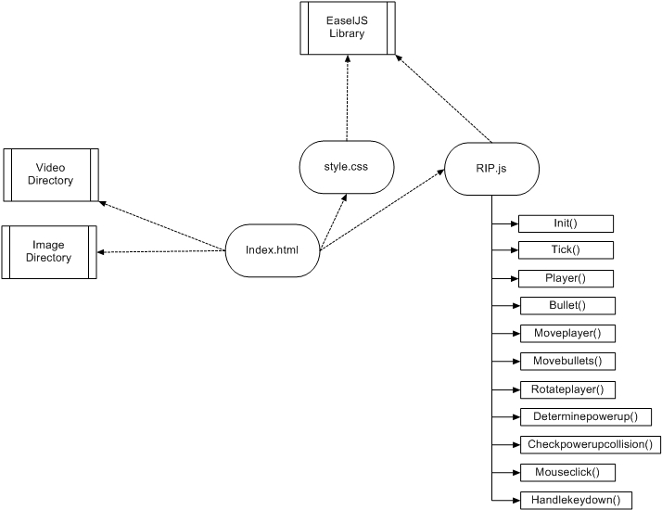

Figure - Code Structure of RIP

Code Structure (see further detail in Readme1):

* Library: EaselJS in the directory: EaselJS-release_v0.7.1
* Internal Resources: Videos (directory) and Images (directory)
* Main page: Index.html
* Javascript source: RIP.js (function breakdown in ‘readme1’ and ‘RIP Flowchart’)

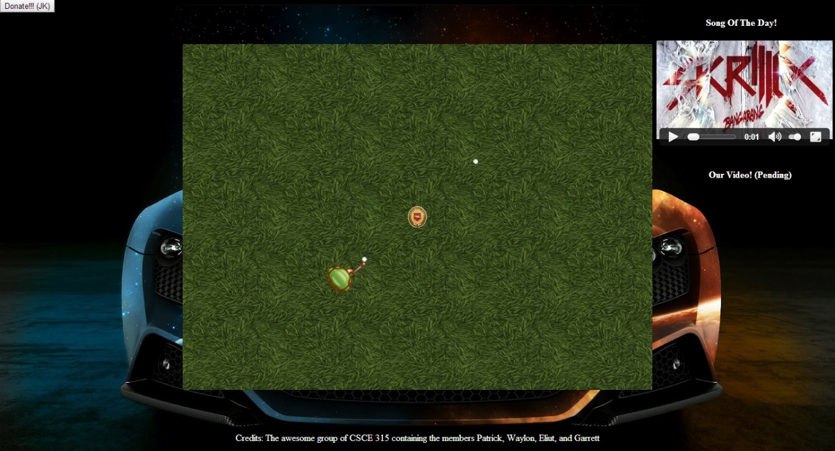

Figure - Screenshot of Requiescat in Pace (RIP)

Meaningful Play:

Our user interface is very intuitive. Players can move around with the very familiar ‘w-a-s-d’ directional navigation, and move the mouse to orient the avatar towards a target. When the multi-user task is accomplished in this game, it will be fast paced and exciting for our players. In our implementation, we used a powerful library (EaselJS) that allows for quick and efficient actions responses which encourages speedy play amongst many users.